Nature’s Wonders: Mary Somerset, Duchess of Beaufort, and the Circle of London Plant Collectors in the Later 17th Century and Beyond

Fulham Palace, Bishop’s Avenue, London SW6 6EA
Tuesday 11 December, 10.00am 3.45pm

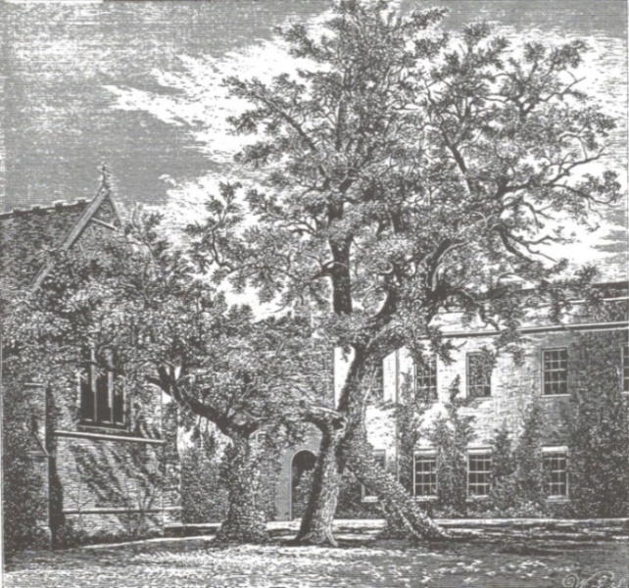
Cork Oak, Fulham Palace

The later years of the 17th and the early 18th century saw an intense interest in botany and plant collecting, in particular of tender exotics. Pre-eminent among London collectors were the Duchess of Beaufort at Beaufort House in Chelsea, Bishop Henry Compton at Fulham Palace (where the Head Gardener was George London), and Queen Mary at Hampton Court. They and the gardeners and botanists who advised them also made herbariums, parts of which found their way into the vast collections of Sir Hans Sloane, which formed the basis for the foundation of the British Museum in 1759.

Professor Mark Laird: The Duchess of Beaufort’s Last Years in London, 1708-1714
Michael Lear: Bishop Compton’s 17th C. and early 18th C. Plantings at Fulham Palace and the Restoration Project
Dr Terry Gough: Queen Mary II’s Exotics at Hampton Court Palace
Dr Mark Spencer: Herbariums and the Early Modern Garden
In the Chair: Dr Todd Longstaffe-Gowan, Gardens Advisor to Historic Royal Palaces

After lunch we will visit the ongoing restoration of Compton’s plantings with Head Gardener Lucy Hart.

Arrival: 10:00 am (coffee and registration) for 10.15 am start in the Drawing Room
Tickets: £65.00 (including lunch and refreshments). Please apply with stamped addressed envelope to the London Parks & Gardens Trust, c/o The Storeyard, St James’s Park, London SW1A 2BJ (tel. 0207 839 3969), or online at https://londonparksandgardens.eventcube.io/events/14688/study-day-natures-wonders . Please indicate any dietary requirements in your application.
Transport: Underground: Putney Bridge, District Line; National Rail: Putney Station; Buses: 74, 220, 430. Car: Parking on Bishop’s Avenue. See www.fulhampalace.org/visitor-information/map-transport-parking.

