W Midlands & S Wales Branch
SATURDAY 20th October 2018,
11:00am for 11:20 entry to the garden.
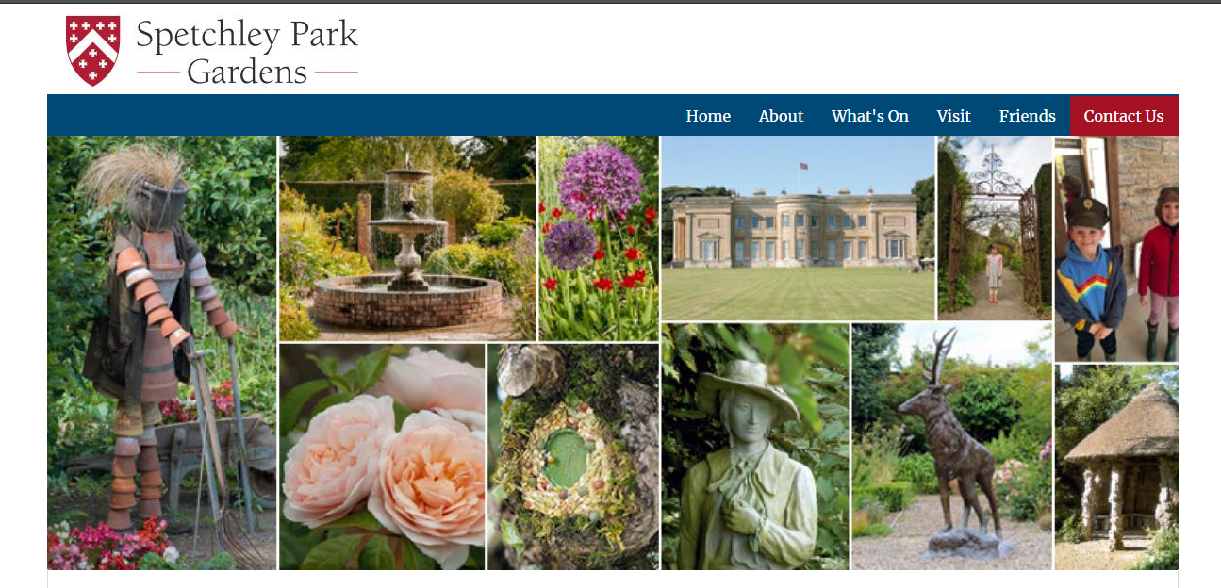
There is a guided tour booked for 11.30 which will highlight the history of the garden and the story behind the plants and trees
Spetchley has been home to the Berkeley family for over 400 years and successive generations have lovingly collected rare plants, shrubs and trees from around the world, creating a wondrous garden of many rooms and vistas that appeal to all ages and tastes.
Surrounded by ancient parkland, deer park and lakes, this historic garden is set in the wonderful Worcestershire countryside with far reaching views to the Malvern Hills.
Lunch – The Old Laundry Tea rooms at the Gardens offer a good range of light lunches, sandwiches, toasties, salad and jacket potatoes etc.
Costs: Entry fee will be £7.00 per person and £6.00 each is there are more than 15 of us on the day.
Directions:
Any additional details:
To register your interest for this visit so we have an idea of numbers or for further details, please contact either Lynn Stevens (Branch Secretary) by replying to this email or Josh Egan-Wyer (Branch Chairman) on 07779 009545.

