W Midlands & S Wales Branch
2018 Annual Branch Meeting.
SATURDAY 9th June, 10:15am for 10:30am start
Visit to THYME where Head Gardener Steve Quinton will give members a tour of the estate.
Thyme is to be found on a Cotswold country estate of 150 acres comprising a boutique hotel; picture perfect cottages; cookery school; tithe barn for dinners, celebrations & corporate events; sophisticated cocktail bar; and restaurant in our country pub The Swan at Southrop.
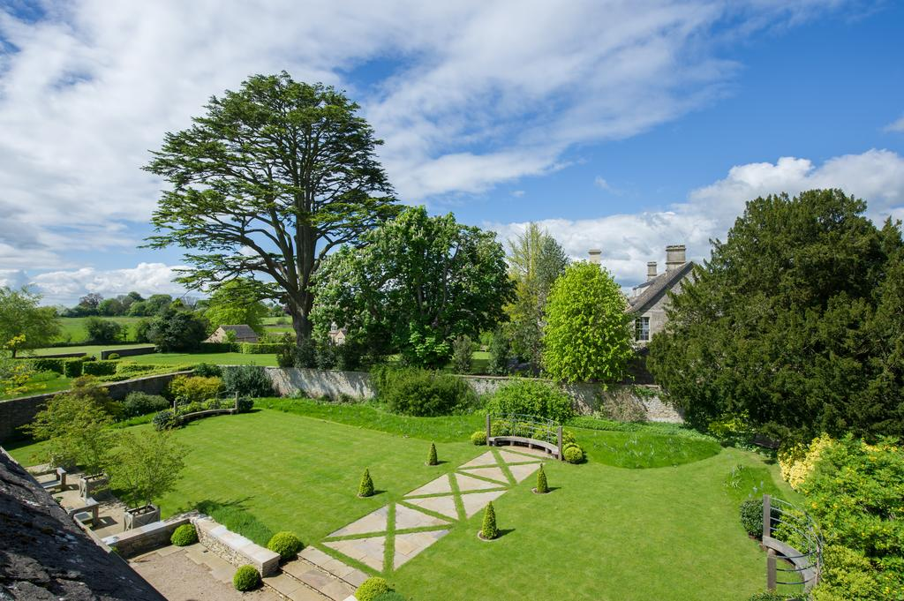
From the sympathetic renovation and rejuvenation of the medieval agricultural buildings to the fully productive kitchen garden & farm at the heart of the brand, ‘for the love of the land’ is a statement that underlines each aspect of the business. The story of Thyme’s development which started in 2009 with their award-winning cookery school, with its program of classes, talks & demonstrations.
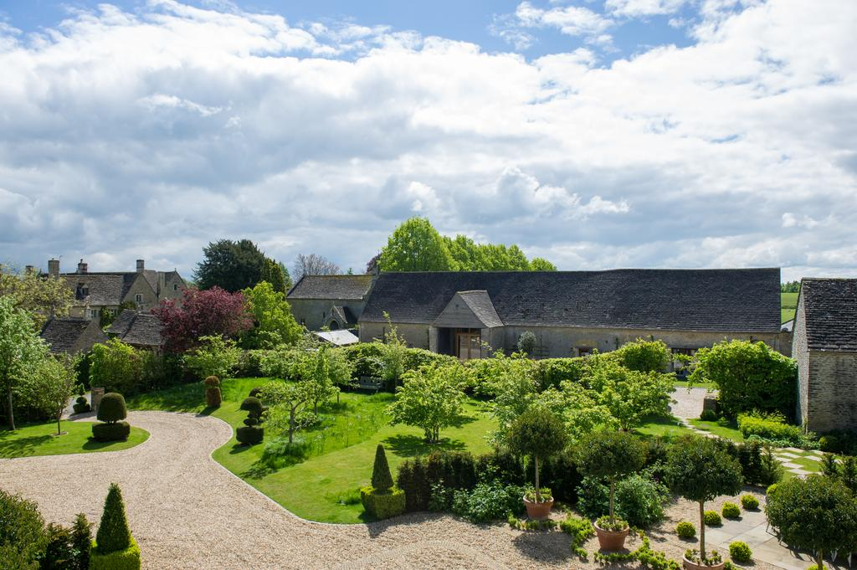

LUNCH: Will be at the Estate Pub. The Swan at Southrop. Steve will bring menus in the morning so you can choose then what you would like to order and it can be sent through ready for lunchtime.
ATERNOON: - AT 2.00pm in the afternoon we will hold the Annual Branch Meeting. All members are encouraged to attend. We look forward to welcoming you. If you arrive just for the afternoon meeting then please call at reception and they will give you directions to the meeting room.
Any costs: This visit will incur members no cost apart from lunch.
Postcodes: GL7 3NX: - please see location map below. 01367 850174
To register your interest for this visit so we have an idea of numbers or for further details, please make contact via the portal [just reply to this email] Lynn Stevens (Branch Secretary).

